**How to launch the Enhancite project frontend, Emotibit software, device**

**Equipments:** A computer 16 GB RAM Windows 10, 11/ MAC, Emotibit device

**Network:** WiFi2.4GHz

**Software:** VSCODE, Nodejs, EmotiBit Oscilloscope, python, python extension in vscode

**Project GitHub page:** <https://github.com/rmit-computing-technologies/Enhancite>

**Some websites to help you to set up Emotibit device,software:**

You can download the Emotibit software here : <https://github.com/EmotiBit/ofxEmotiBit/releases>

You can find how to start the Emotibit device here :<https://github.com/EmotiBit/EmotiBit_Docs/blob/master/Getting_Started.md>

You can find Emotibit data details here: <https://github.com/EmotiBit/EmotiBit_Docs/blob/master/Working_with_emotibit_data.md/#EmotiBit-Oscilloscope>

You can ask questions, find solutions here: <https://www.reddit.com/r/EmotiBit/>

**1. Launch the frontend**

1.project clone/ download

<https://github.com/rmit-computing-technologies/Enhancite>

This is the project GitHub link, you can download the project or clone the project on your computer.

1.The basic project looks like:

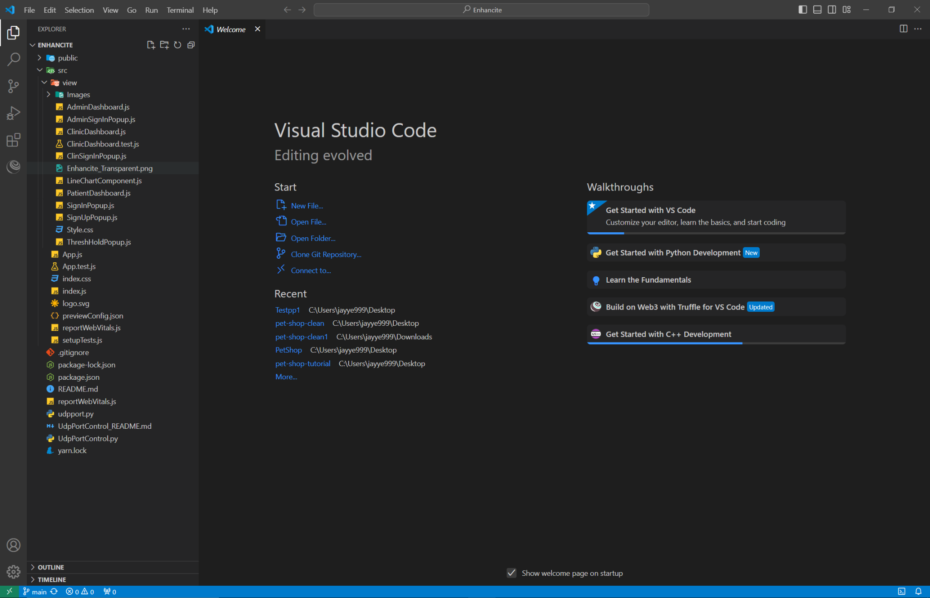

2.Open the terminal in vscode, input “ npm install ”

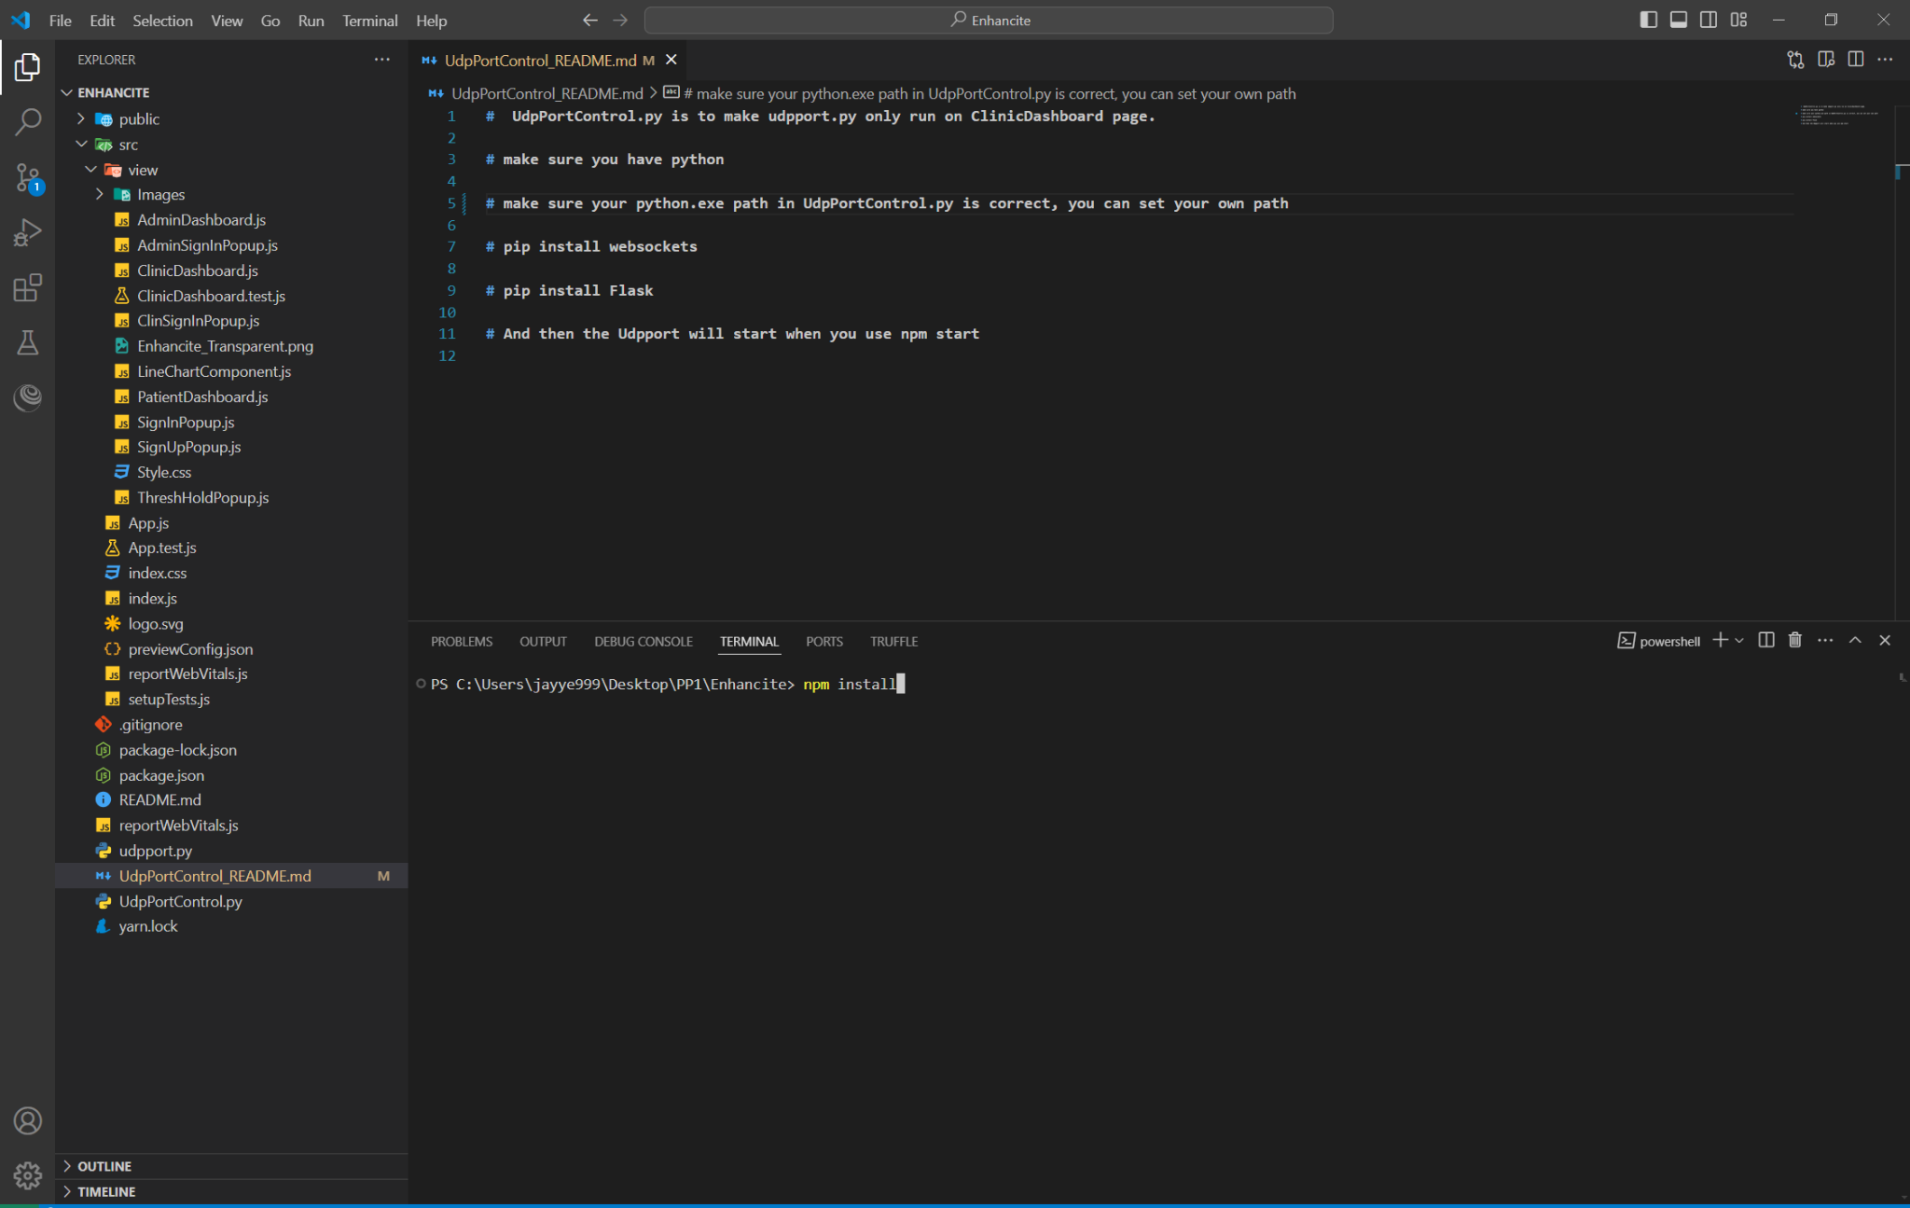

3.After installation, you can find a folder called node_modules in your file

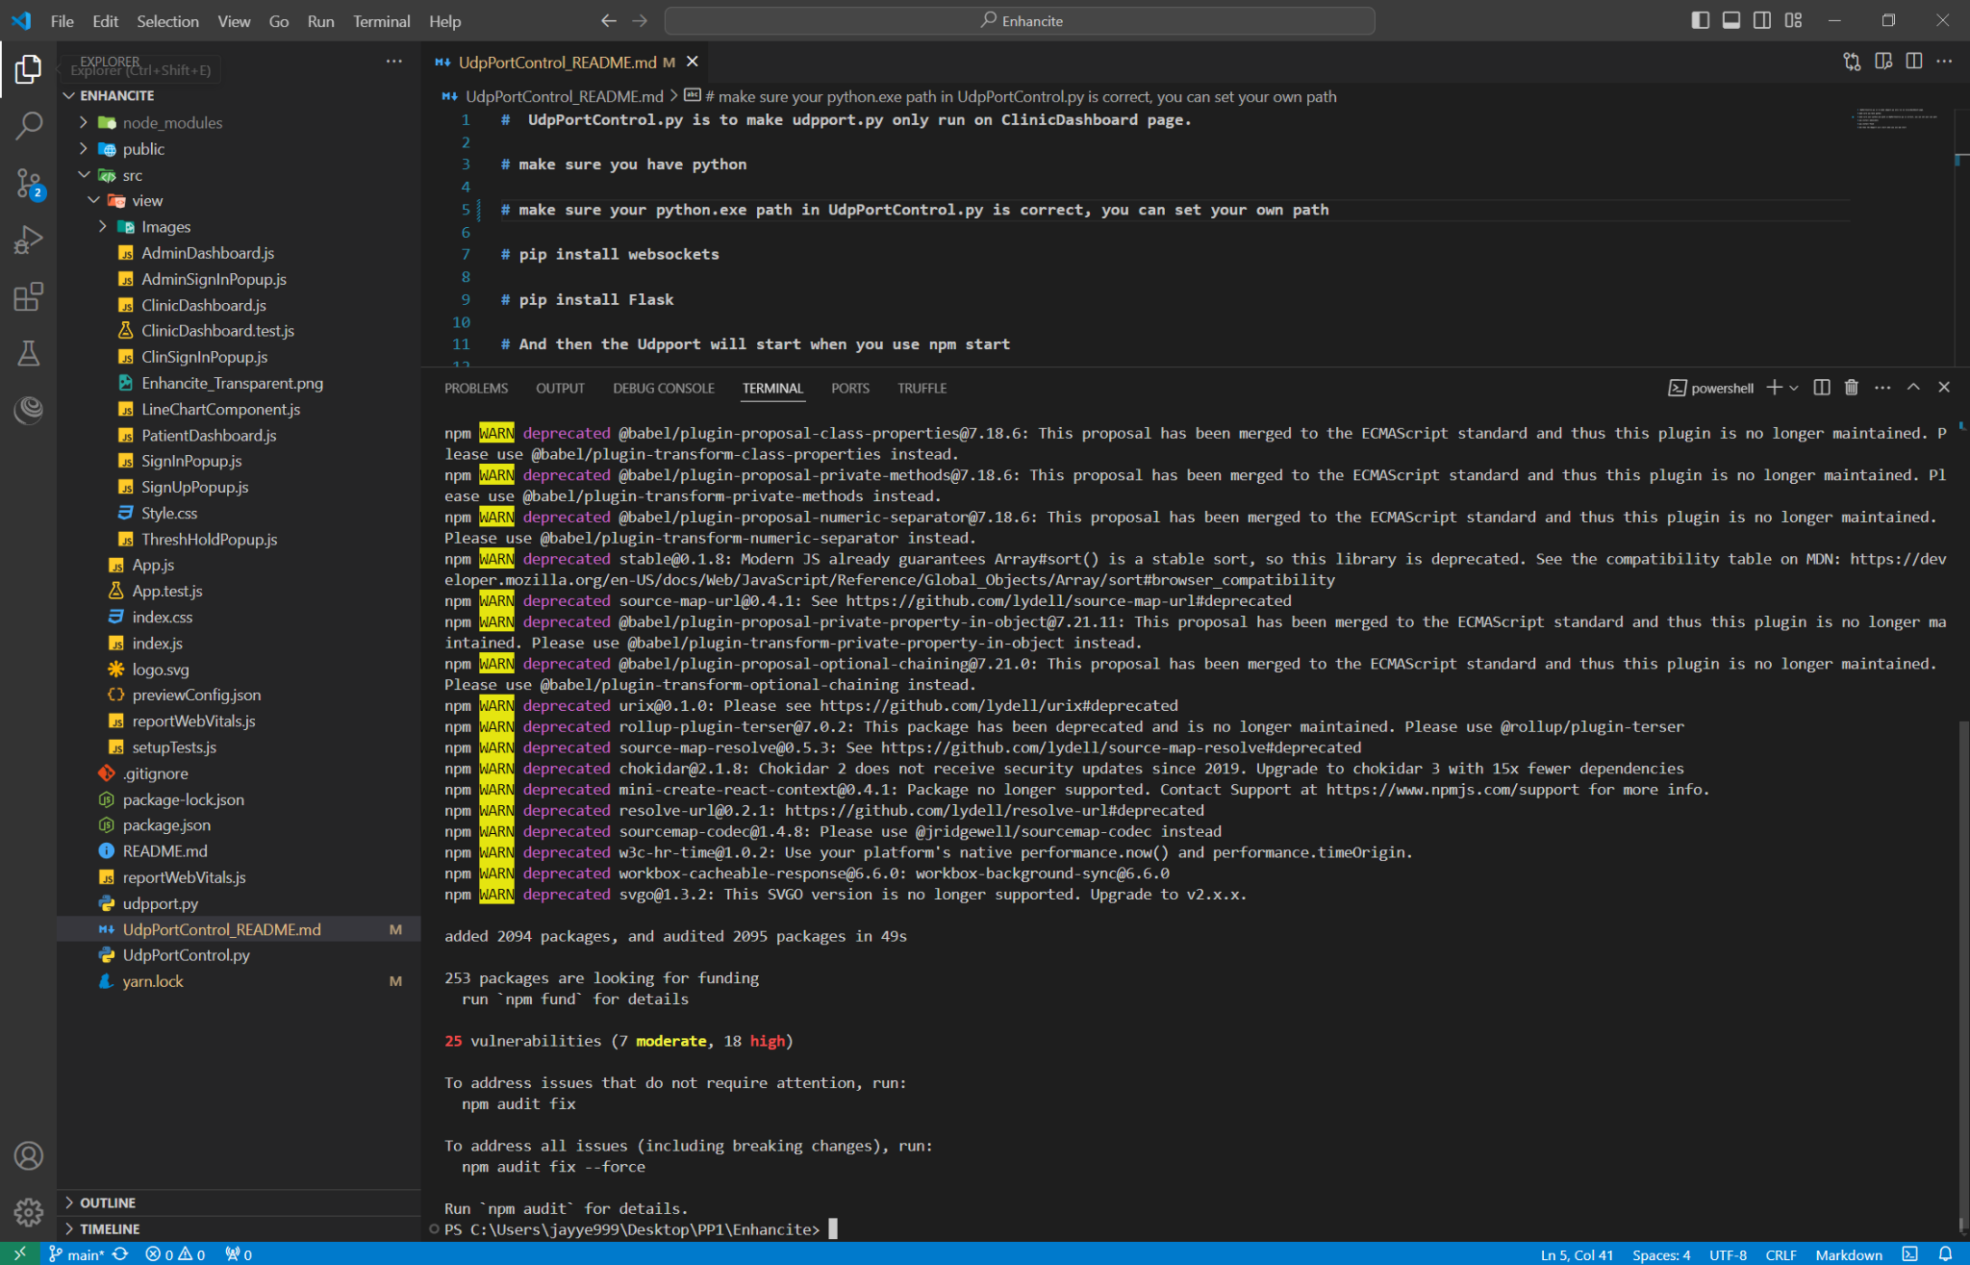

4. Now you can check the UdpPortControl_README.md. Make sure you have python installed on your computer .

4.1 go to terminal, input “pip install websockets”, the vscode may show a window to tell you to create a virtual environment. You should choose to create.

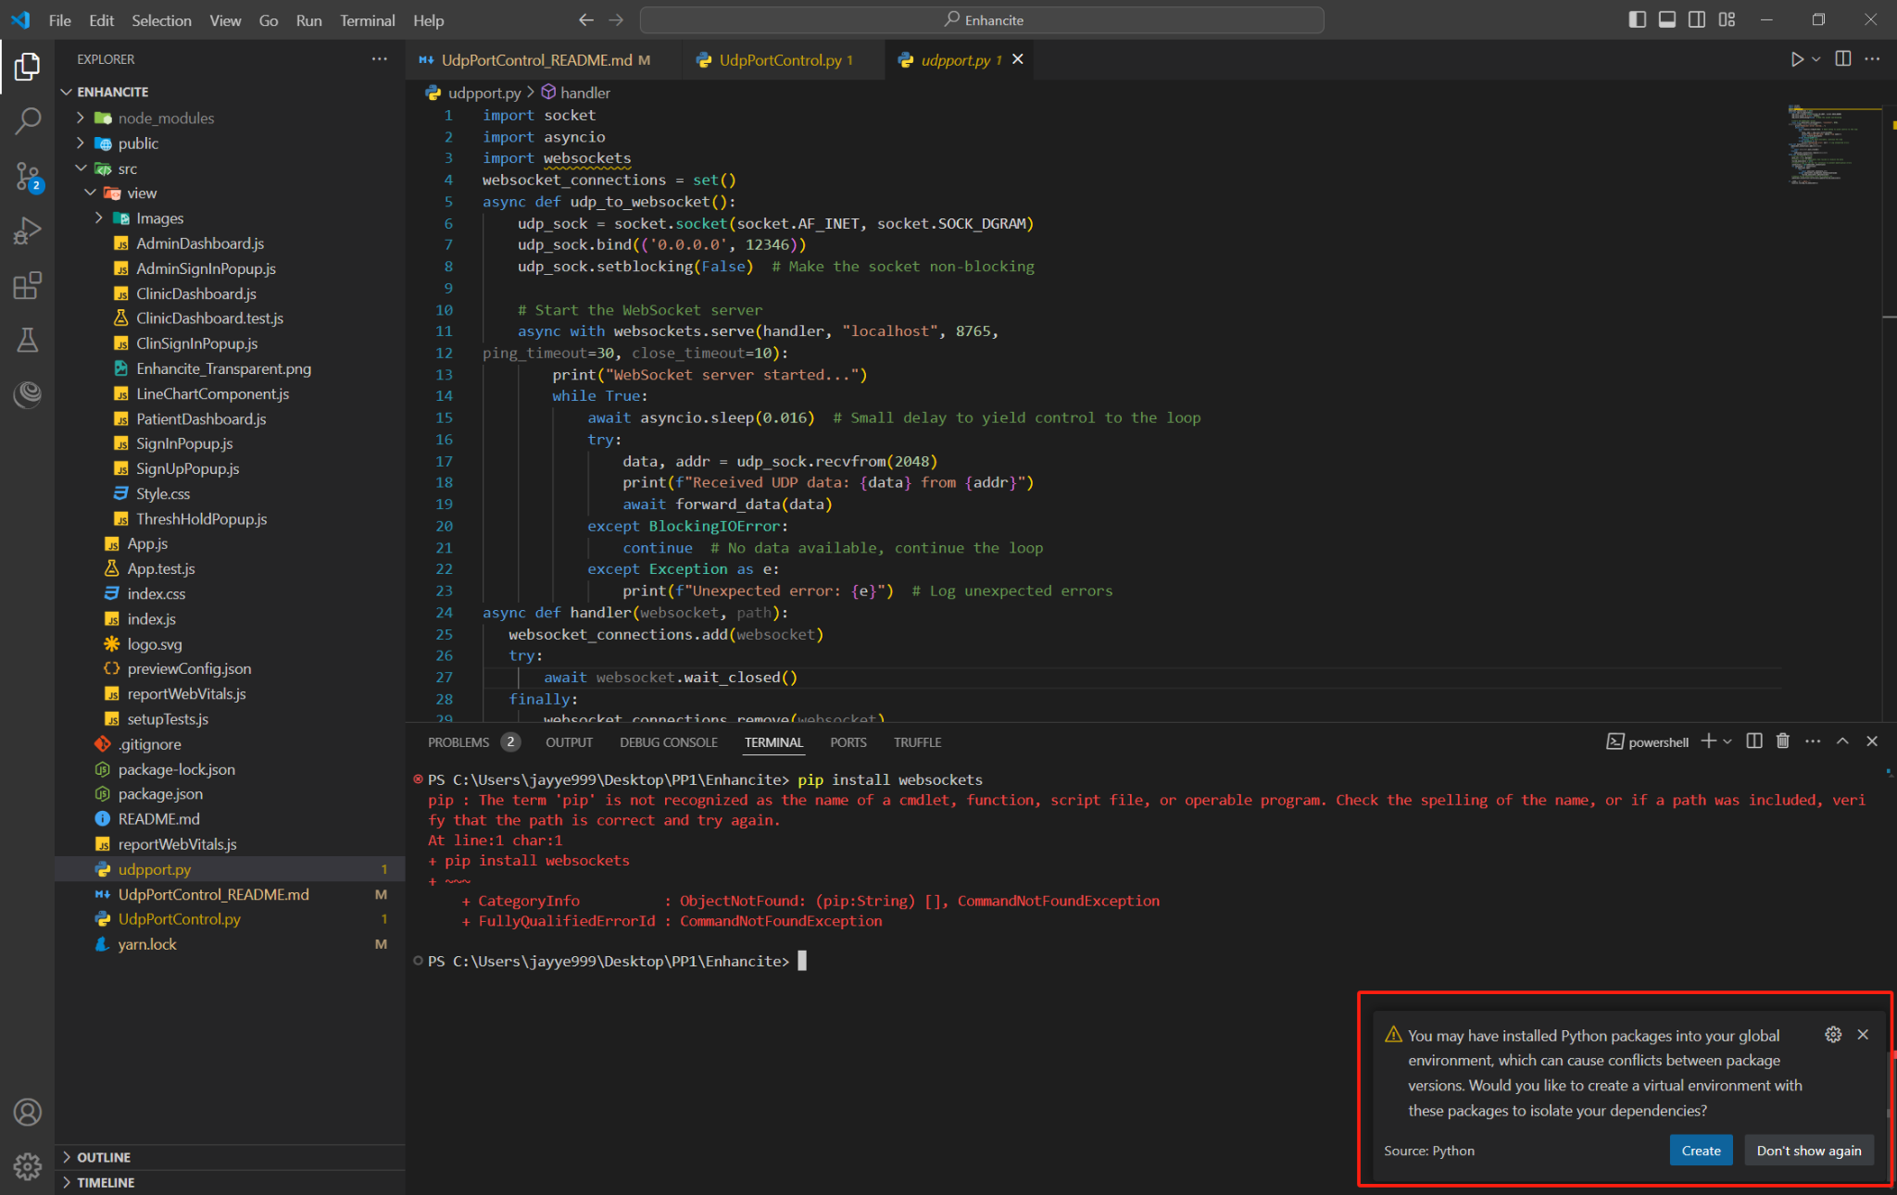

4.2 Choose your Global Python interpreter

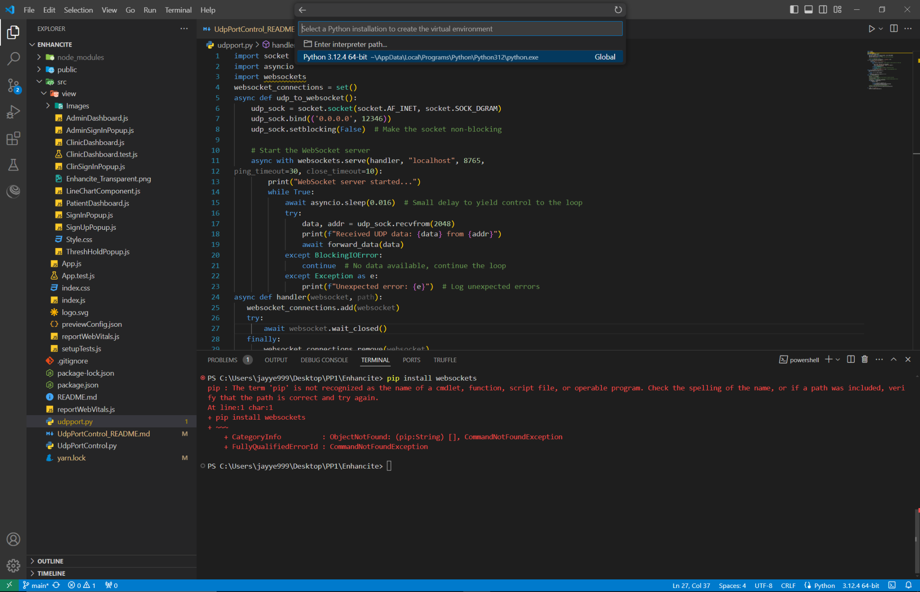

4.3 After virtual environment installation, you should see a folder called .venv in Enhancite folder, and you can see the websockets has been downloaded.

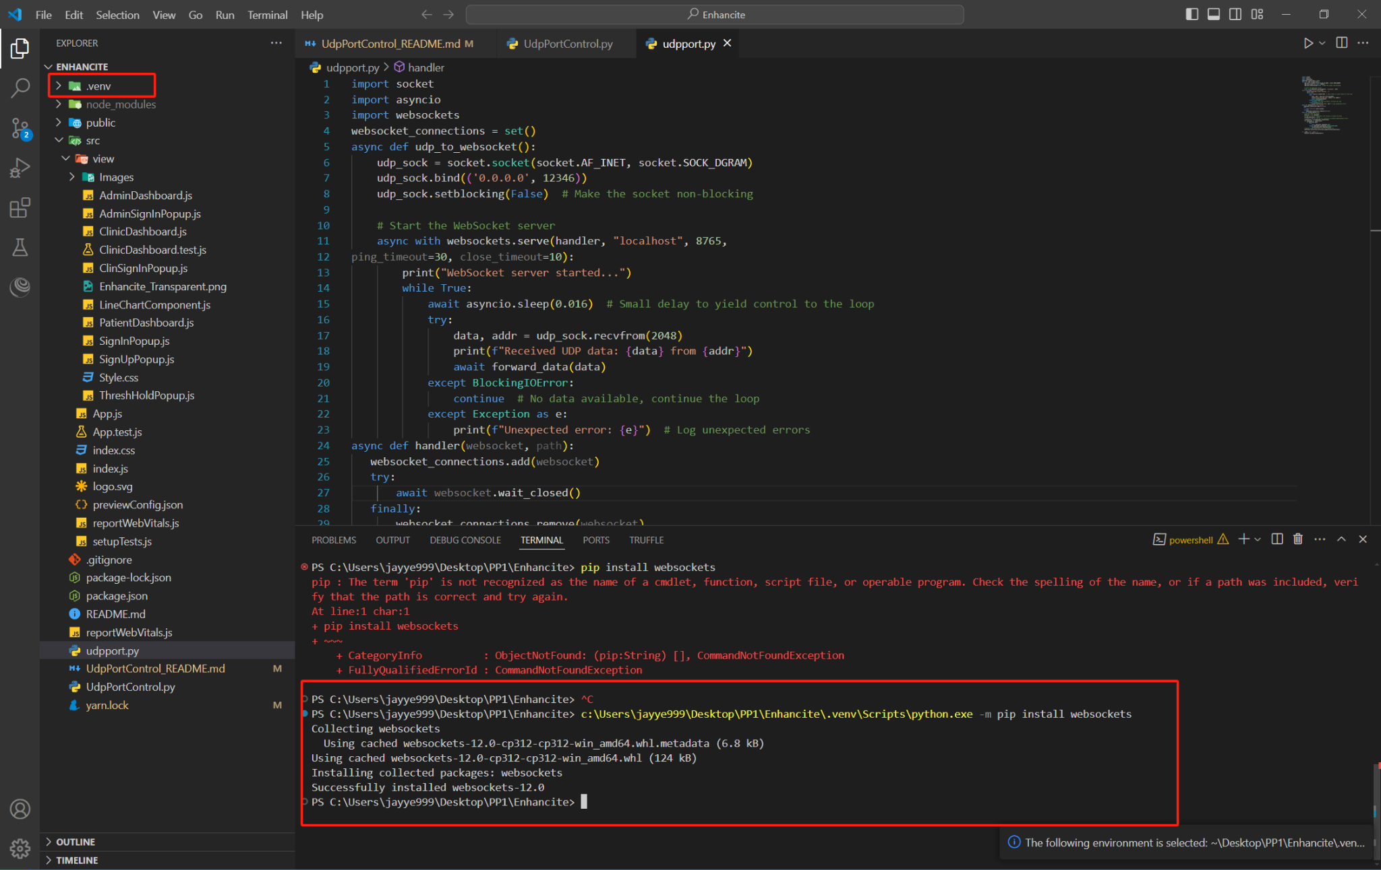

4.4 And we will install the flask.

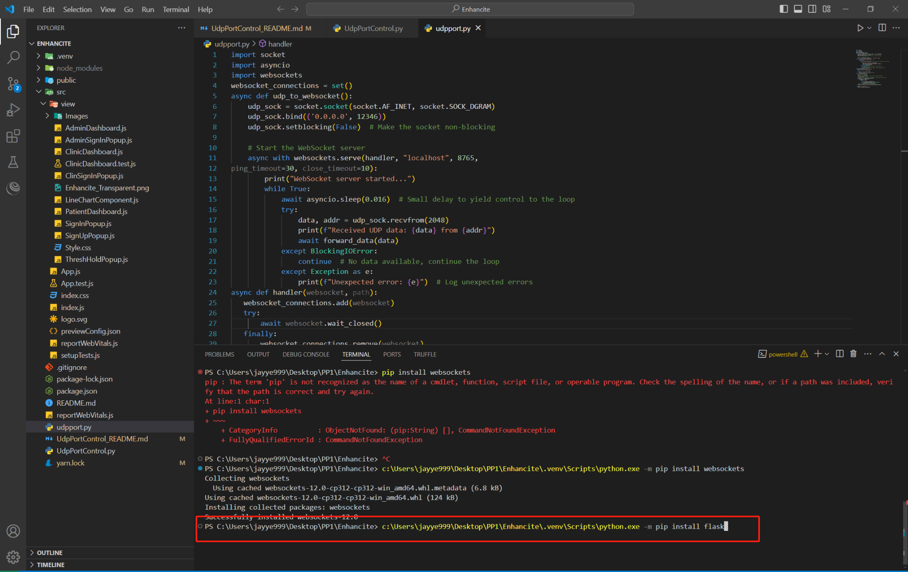

Flask installation finished

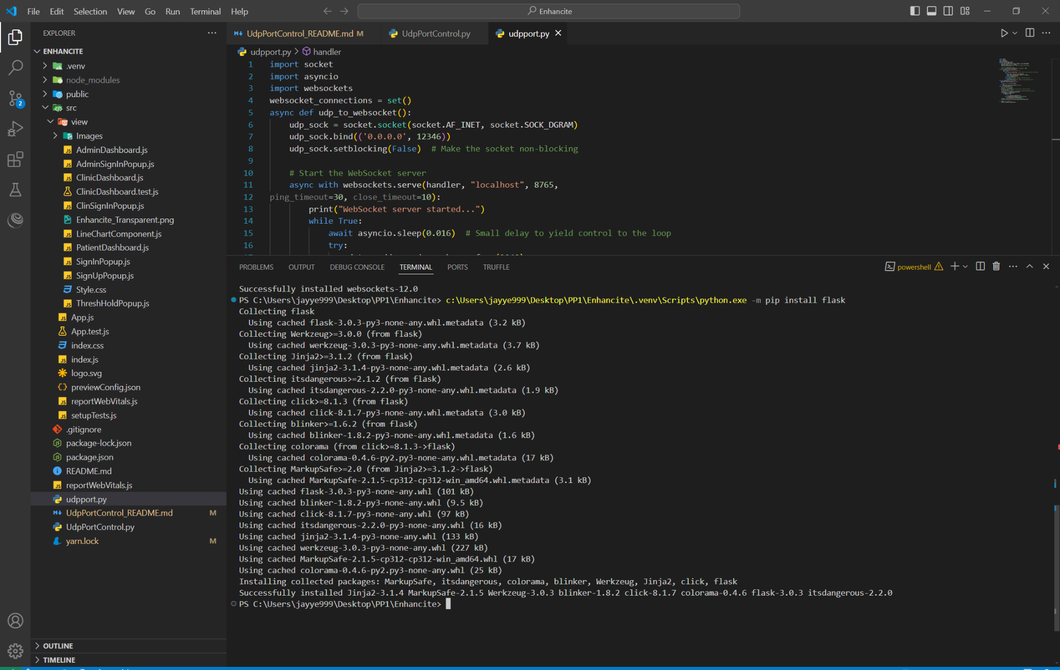

4.5 Now you can edit your python.exe path in UdpPortControl.py, because I set a virtual environment, the path should be c:\Users\jayye999\Desktop\PP1\Enhancite\.venv\Scripts\python.exe

So, I should replace python to c:\Users\jayye999\Desktop\PP1\Enhancite\.venv\Scripts\python.exe

But you can use any python.exe, as long as the python has the flask and websockets components.

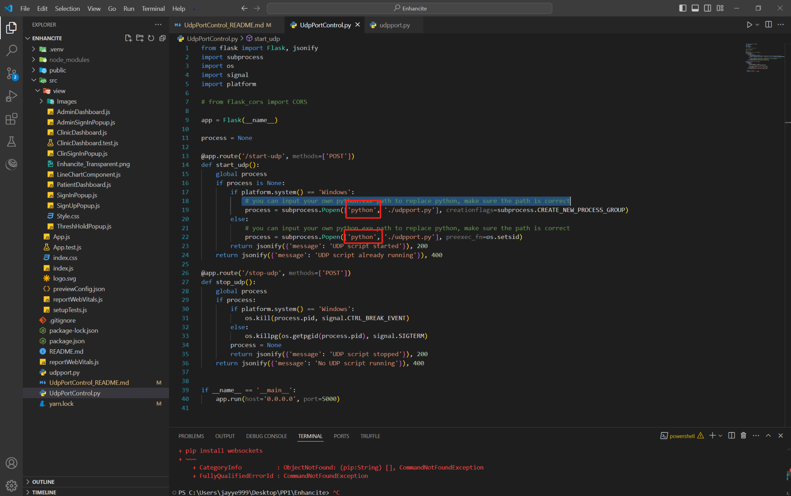

4.6 Test run udpport.py

udpport.py, if the terminal shows webSocket server started, it should be ok for udpport.py

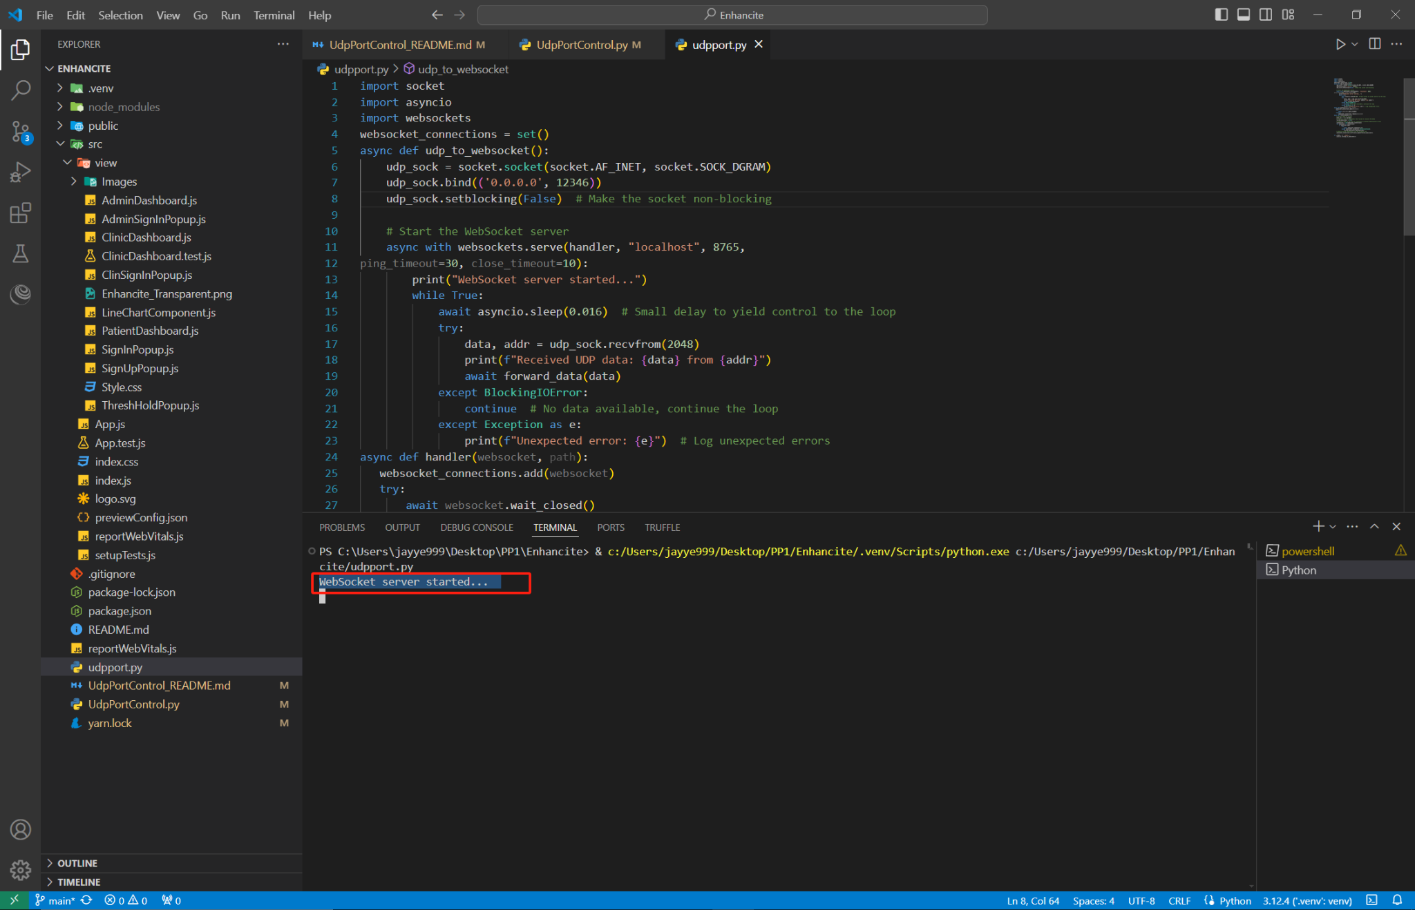

5. Launch the project

Open terminal, input “npm start” to launch the project.

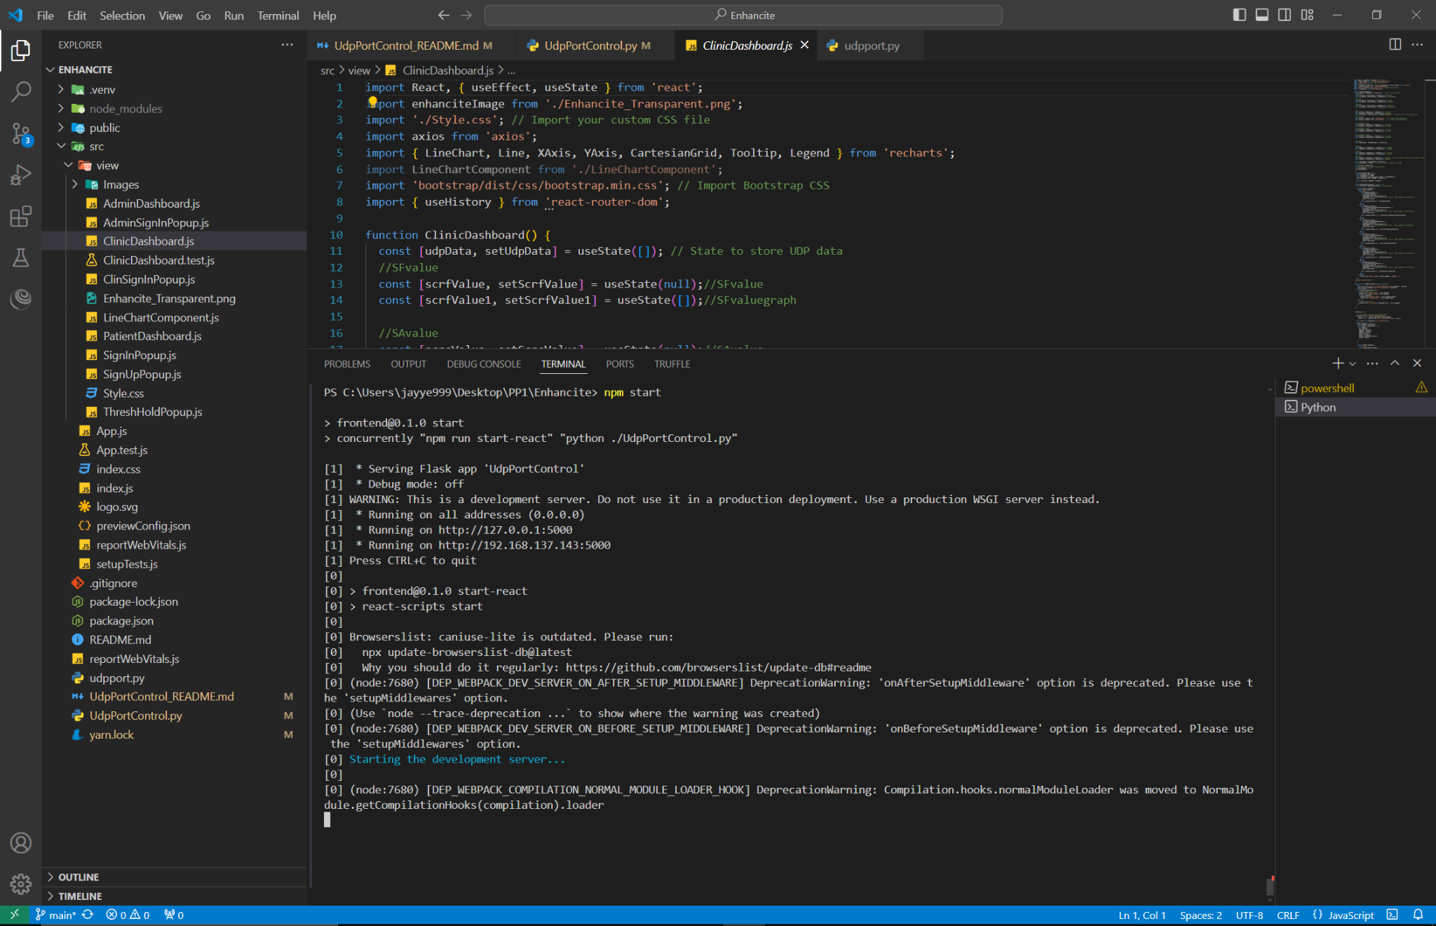

Make sure the UdpPortControl.py is running

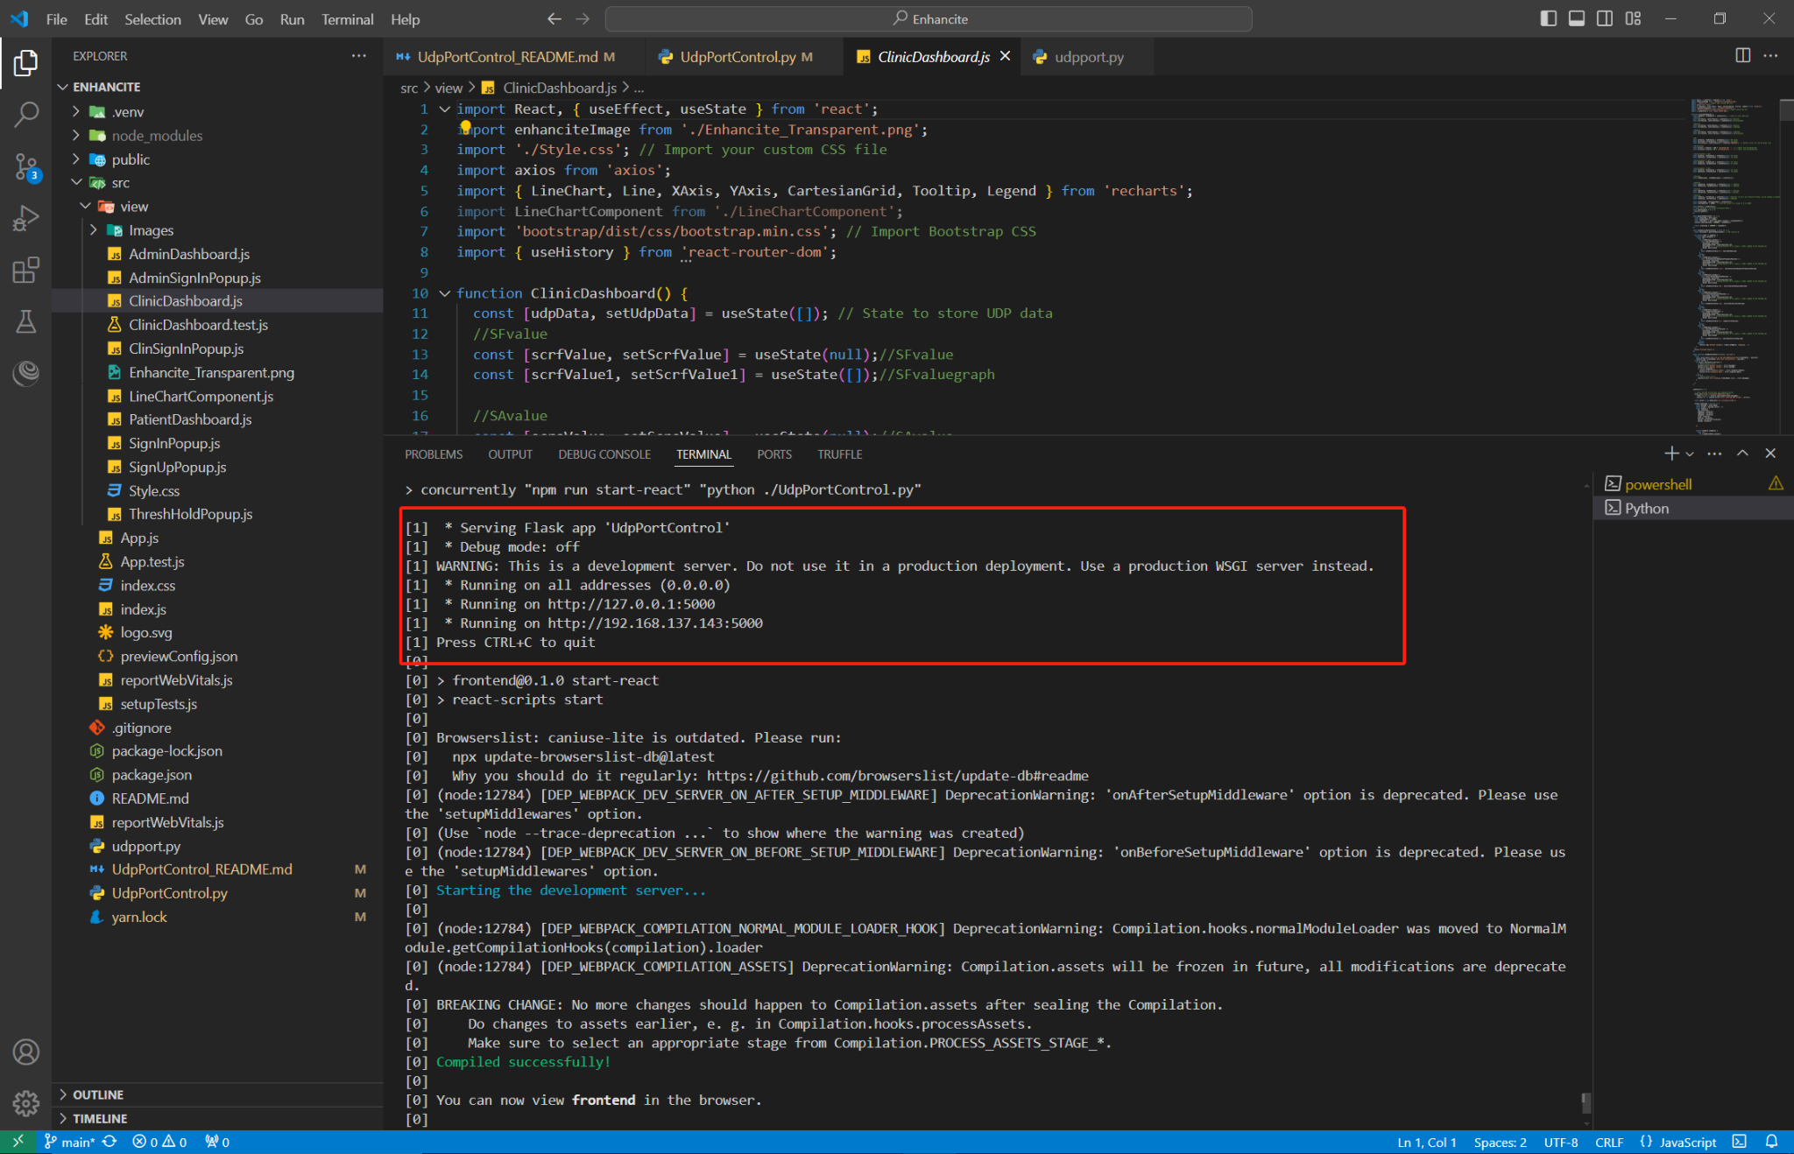

A window will pop up in the browser

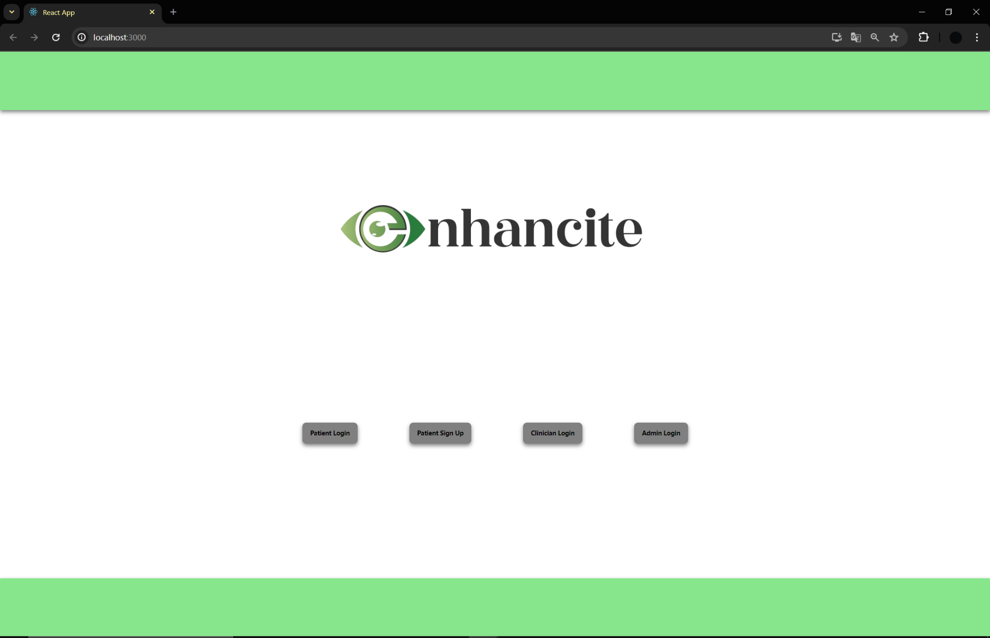

Click Clinician Login, and login, you don’t need any username and password. And the ClinicDashboard page will show.

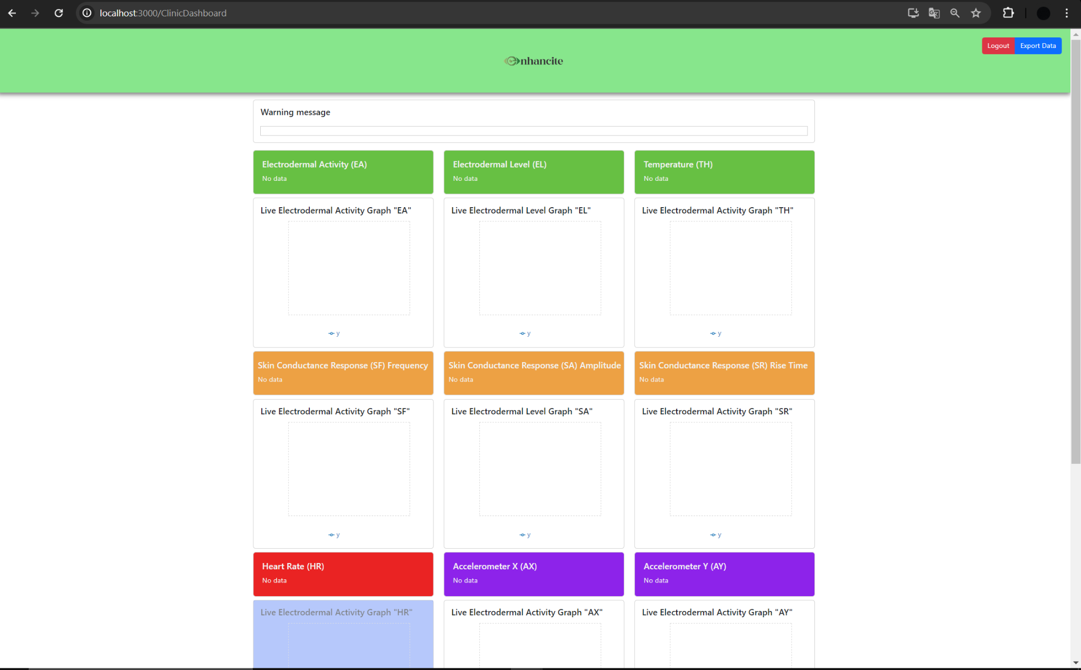

**2. Emotibit device download, setting**

**Some websites to help you to set up Emotibit device:**

You can download the Emotibit software here : <https://github.com/EmotiBit/ofxEmotiBit/releases>

You can find how to start the Emotibit device here :<https://github.com/EmotiBit/EmotiBit_Docs/blob/master/Getting_Started.md>

You can find data details here: <https://github.com/EmotiBit/EmotiBit_Docs/blob/master/Working_with_emotibit_data.md/#EmotiBit-Oscilloscope>

You can ask the questions, find solutions here: <https://www.reddit.com/r/EmotiBit/>

There are many version, I choose the latest version for now v1.11.1

And I downloaded the EmotiBitSoftware-Windows.zip.

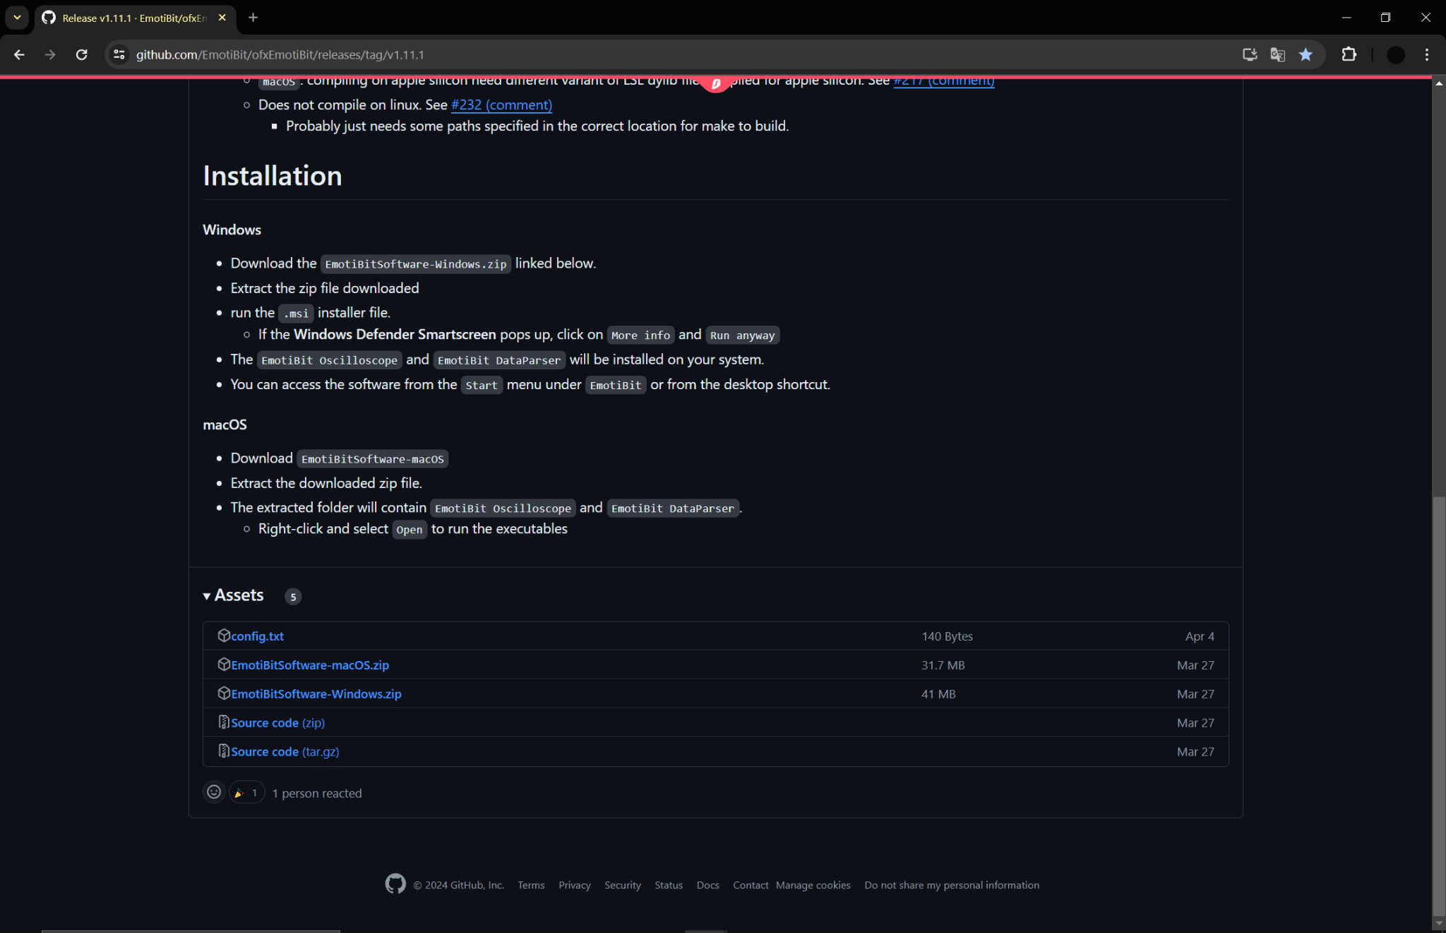

After downloading, and extracting the folder, you need to use the msi installer to install the Emotibit software on your computer.

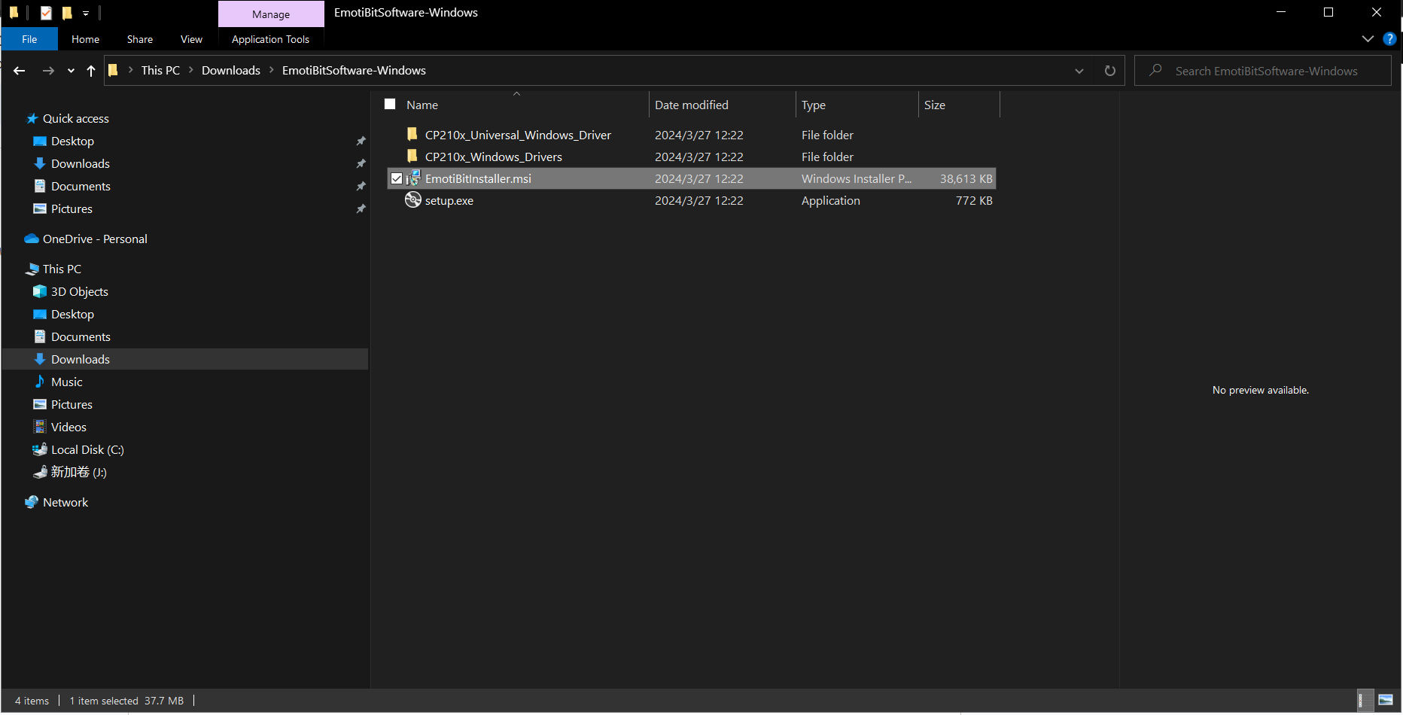

After installation, you can have these 3 softwares. You will need to use Emotibit Oscilloscope to do real-time data transmission.

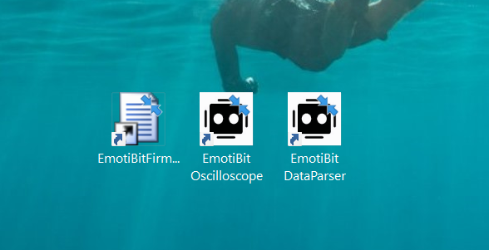

**After you download the software, you need to start the Emotibit device** :<https://github.com/EmotiBit/EmotiBit_Docs/blob/master/Getting_Started.md>

You need to Add your own Wifi credentials, the wifi has to be 2.4GHz, you can use your phone’s hotspot, but it will be very slow. I recommend you have 2.4GHz wifi. Or you can use a mobile hotspot from another computer which is my way.

The config.txt is in the sd card.

ssid is your wifi name

Password is your wifi password

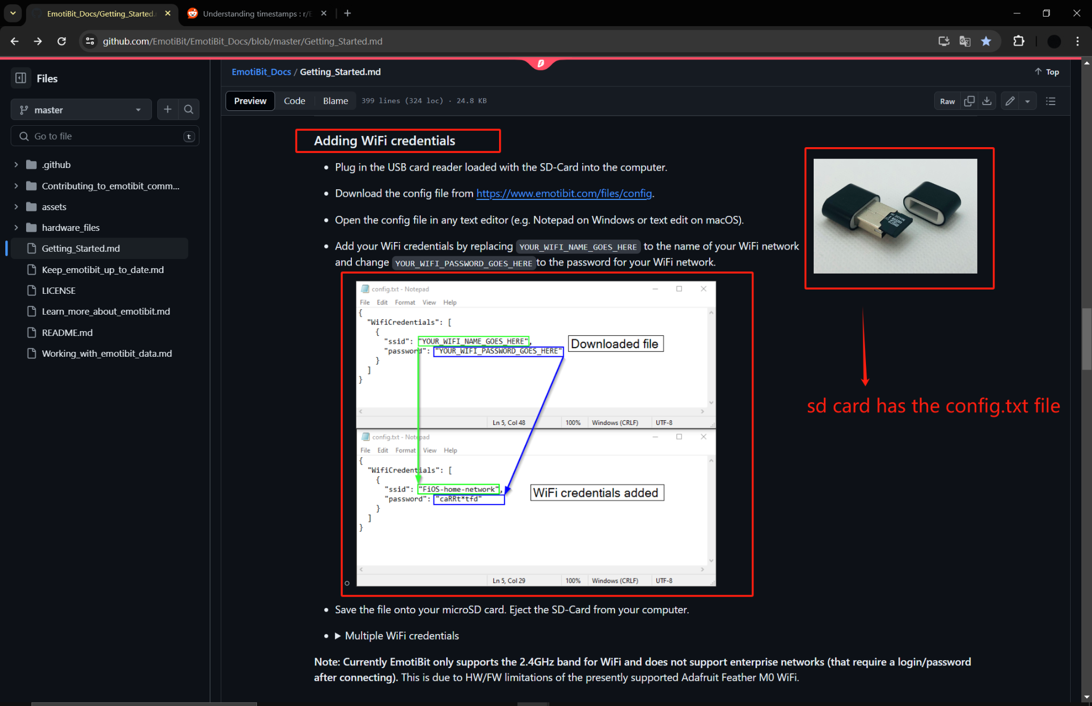

You can launch your Emotibit device, and Emotibit Oscilloscope, your computer, and Emotibit device needs to connect to the same network.

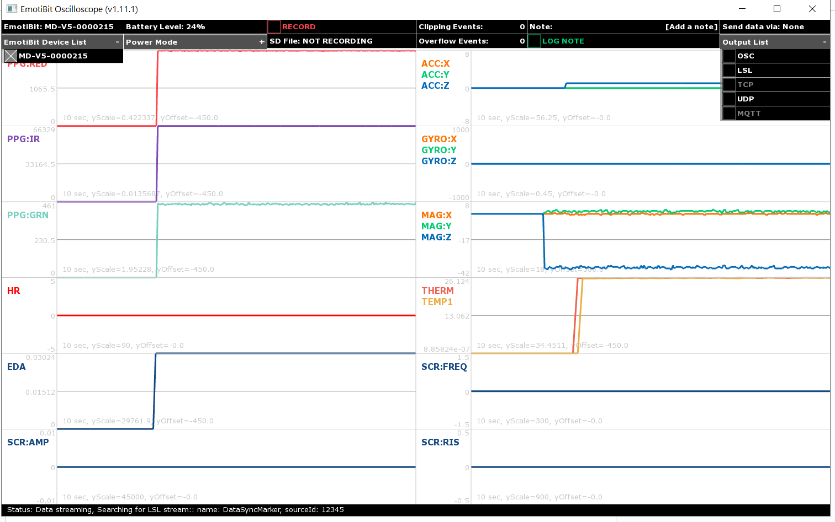

**3.Run the project, Emotibit software and device**

Now you should be able to launch the Enhancite project, Emotibit device and Emotibit software. It is time to show the real-time graphs now.

1.You need to start the device, software, and choose the UDP port for the output list.

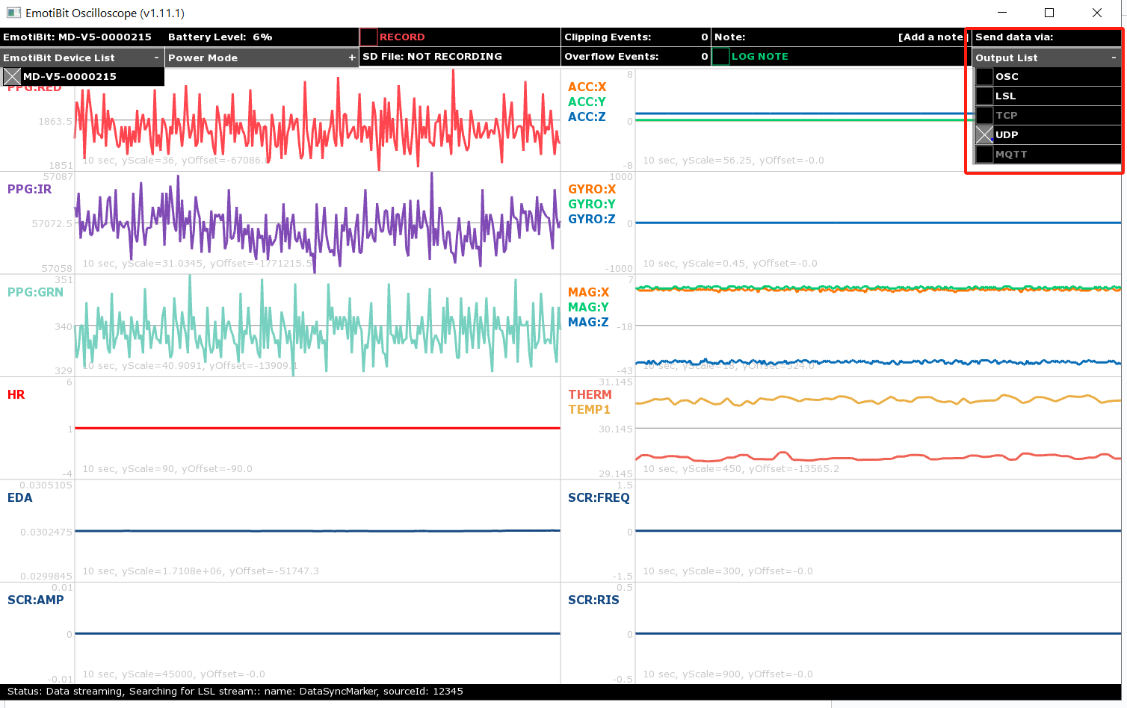

2.At the same time, you need to launch the Enhancite project. And go to the ClinicDashboard page, you will see the real-time graphs are generated.

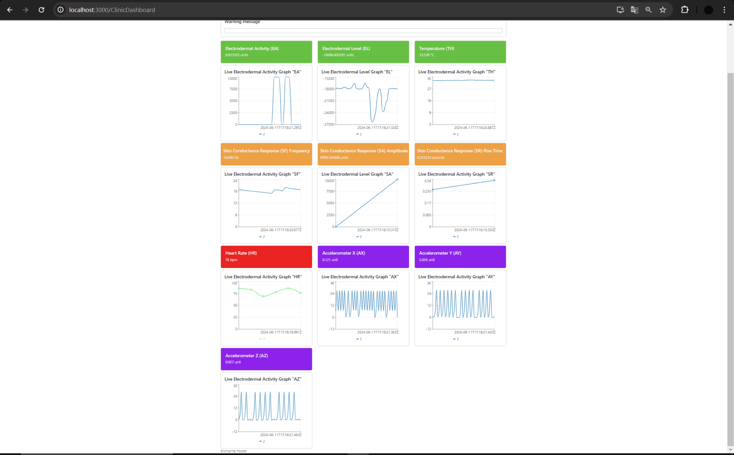

3. You can click export button to export data to backend

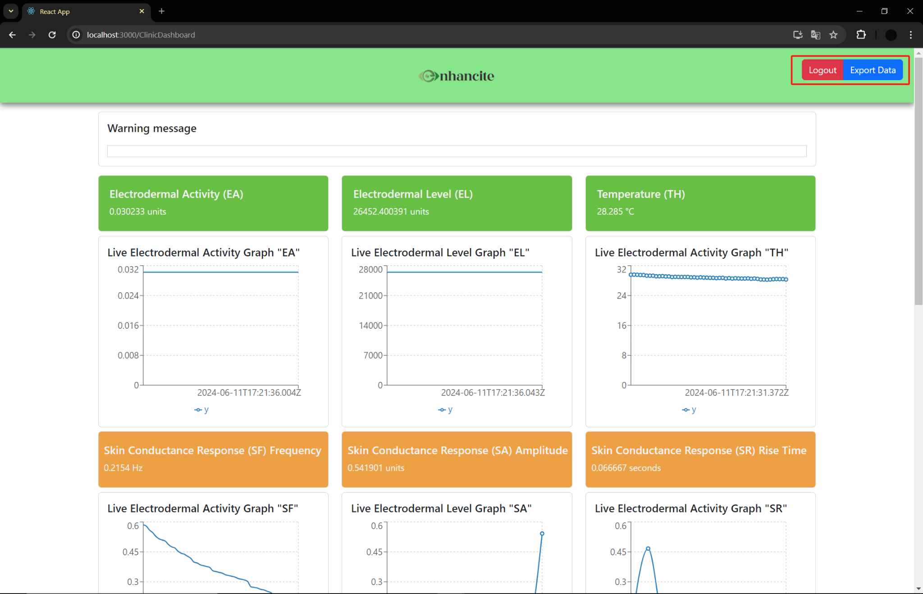

4. We only do 10 data streams, but Emotibit provides more than that. You can find data details here: <https://github.com/EmotiBit/EmotiBit_Docs/blob/master/Working_with_emotibit_data.md/#EmotiBit-Oscilloscope>

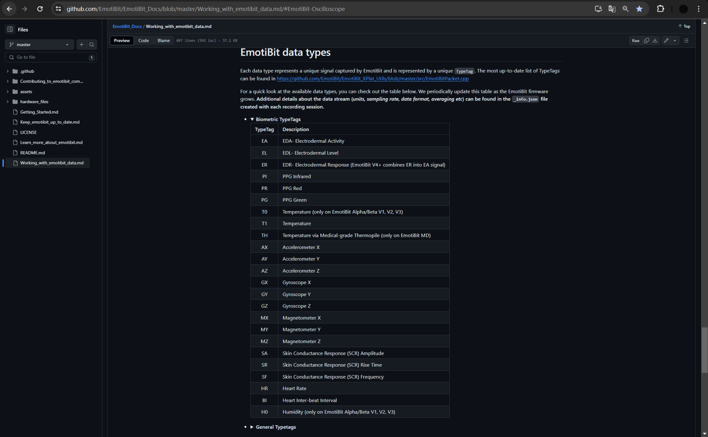

Thank you!

Tianlang Huang